

FITTING OFF &

INSTALLATING

CENTRAL VACUUM

SYSTEMS

Central Vacuum Warehouse
Phone: 0800 550 553
www.centralvacuumwarehouse.co.nz
sales@centralvacuumwarehouse.co.nz

INTRODUCTION

This information is distributed to all buyers of Central Vacuum Systems. It contains information which will be valuable to those who install their own systems and also to those who have the installation performed by installers.

Your system is designed to last the life of your home. Like all other electrical or mechanical equipment, timely maintenance and care will ensure its trouble free operation.

Should troubles occur, don’t hesitate to seek advice from Central Vacuum Warehouse

FITTING OFF THE CENTRAL VACUUM SYSTEM

Step 1: Over View
When you come to fit off the Central Vacuum System firstly refer to your site plan and make sure all inlets are coming through the wall lining in the correct position, remove the cover plate and check that the cable is inside the pipe, do the same for the Inlet at the Motor end

Step 2: Install the Power Unit
While the information below is for a Hills 1600 Central Vacuum which is the most common model we sell, the same rules apply for all Vacuums

When you come to fit off the Central Vacuum System:
- Take the vacuum out of the Box
- There will be an instruction manual in the box at the top, we recommend that you read this
- There will be a packet of fittings in the Top of the Box
- Un wrap the vacuum from the Plastic cover
- Remove the Bin part
- Remove the Cone, see Pics below,
- The wall mounting bracket is in the Bin, also check there are no fittings in there as well

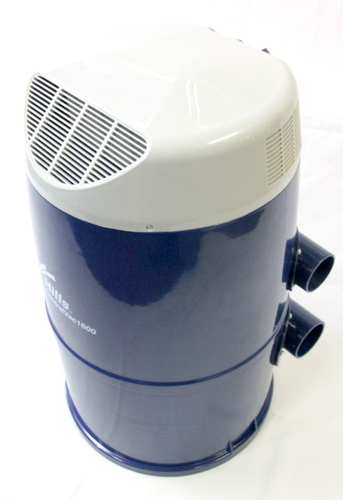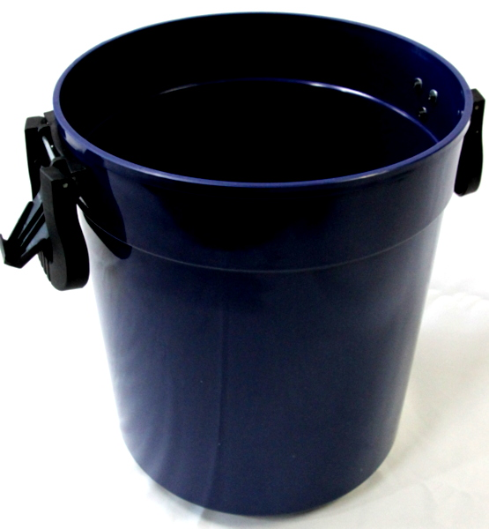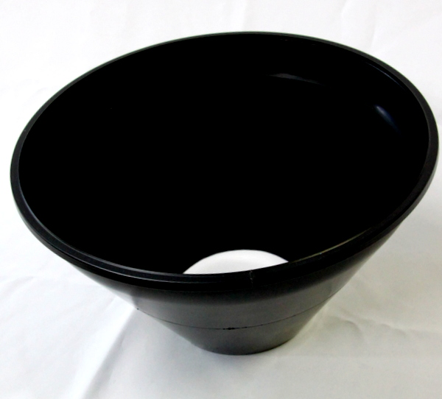
The Top Motor part has:
- 1 Hole on the Left side when you are looking at it, this is an Inlet and usually has an Utility Inlet in it
- 2 Holes on the Right side as in the picture,
- The Top Hole on the Right is the exhaust Outlet
- The Bottom Hole is the Vacuum Inlet
The Inlets on the Left and Right are interchangeable and which one you use is determined by which side of the pipe that comes out of the wall that you want to mount the Vacuum on.

If you want to use the left Inlet then the Utility Inlet can be taken out of the left Inlet Hole and installed in the Right Inlet hole, to do this carefully remove the Utility Inlet using a screw driver being careful not to damage the Plastic housing and re install in the other side

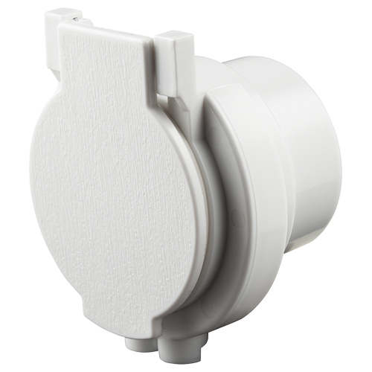
The Utility Inlet is turned ON / OFF by the switch on the top Right of the motor.

Now Decide on the Motors Position:
- Put the Mounting bracket into the back of the Motor
- Hold the Top part of the Vacuum Motor and Mounting Bracket against the wall to get the general area it needs to be in and mark the wall where the bracket wall with a pencil,
- Try to line up the Vacuum pipe coming out of the wall with the inlet on the Motor so they are horizontal
- Find the nearest Stud in the wall to your proposed mounting location, (the Vacuum is 300mm wide).
- The Vacuum MUST BE fixed to a Stud using BOTH upright screw holes. DO NOT screw into the lining board only unless you use Metal Toggle Bolts, (NOT Plastic)
- Hold up the Vacuum mounting bracket against the wall and mark the holes with a pencil
- Drill a small pilot hole to make sure you are going into a Stud with both screws

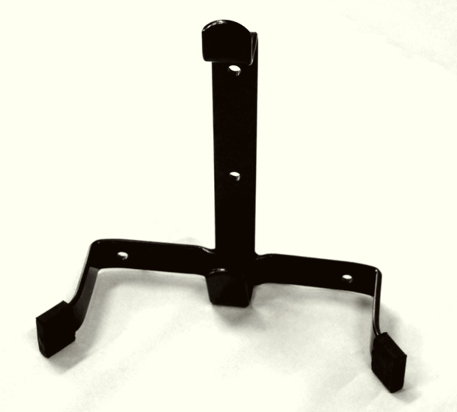
- Hold the Top part of the Vacuum Motor against the wall to get check that the Vacuum pipe coming out of the wall lines up with the inlet on the Motor so they are horizontal
- Now Check that the Mounting bracket is Vertical
- Mark the screw holes for the 2 screws holing the bracket at the bottom
- If they are not going into wood behind the lining board use toggle bolts type screws, see picture below
- Fix the bracket to the wall using two screws 50mm long into the top two holes
- Screw two screws 50mm long into the bottom two holes OR use two toggle bolts
- Mount the Motor, making sure it is Vertical

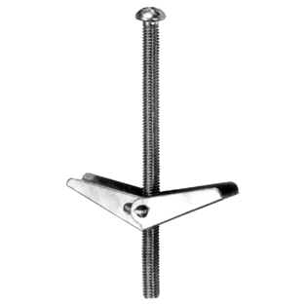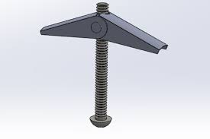

Step 3: Connect the Pipe to the motor
Connect a Sweep 90 bend OR Tight 90 bend coming out of the Wall; use the bend that best lines up with the Motor Inlet Connect the Pipe to the Power unit.

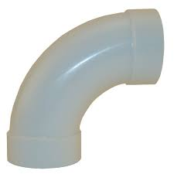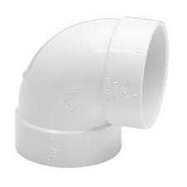

Measure the distance to the Motor Inlet and add 30 MM to the length, (20MM to go into the Motor Inlet and 10mm into the bend coming out of the Wall)
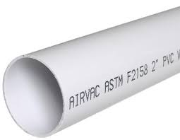
Cut and join the pipe (it will be a tight fit into the Motor Inlet)
Do not glue these joins, just tape them.

Step 4: Connect ON / OFF Cable to the Motor
Now Connect the ON / OFF wire to the Vacuum, using the fittings supplied see below. There should be 2 cables coming out of the wall, bare back the cable and clamp it to the Push on Connector. Then push the Push on connector to the terminals on the top left of the Vacuum, making sure that the push on connectors are not touching each other
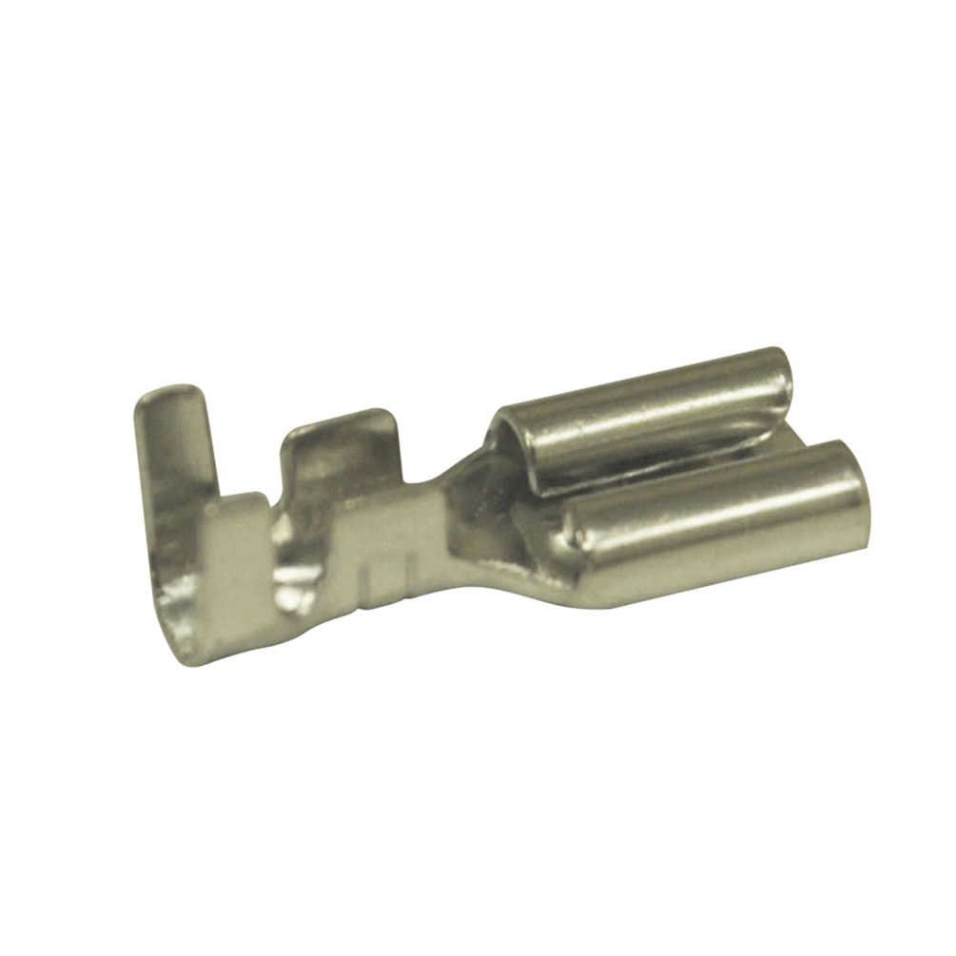
Tape the cable to the back of the Vacuum pipe so it is tidy and feed up through behind the motor.

Step 5: Connect the 230V Power lead to the Motor and Plug it in,
Feed it up behind the motor so it is tidy

Step 6: Connect the Bin
Make sure there is a filter in the Motor; the Filter is held in with a clamp that will unscrew
The Filter Clamp:
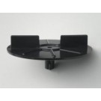
The Filter:

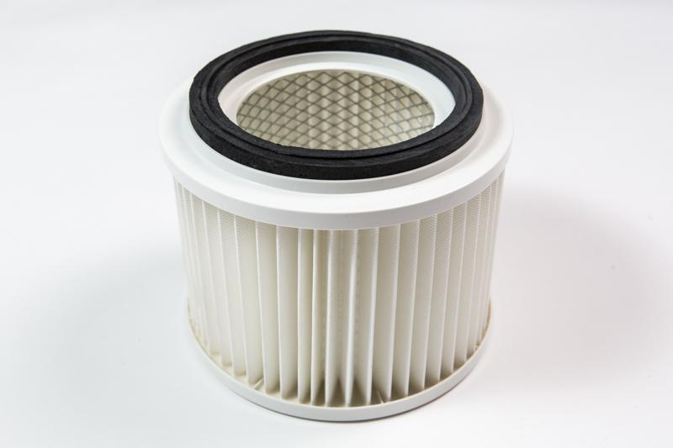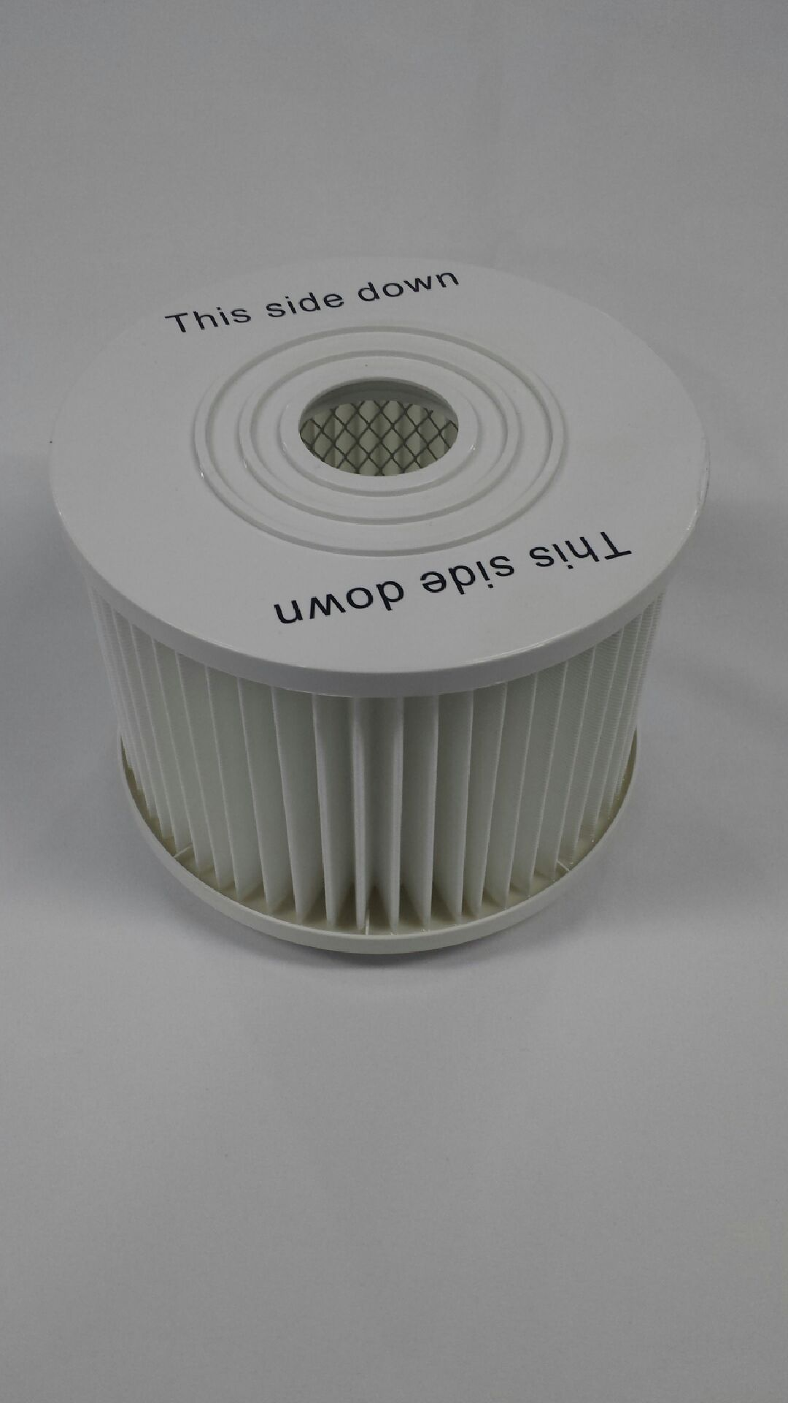

Put the cone in the bin making sure the rubber seal is around the Cone and connect to the motor

Step 7: Install the Hose Holder
Install the hose holder on the wall close to the Power Unit, making sure it is screwed to a Stud OR use Metal Toggle Bolts
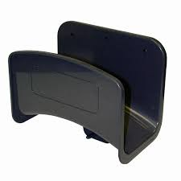

Step 8: Install the Inlet Valves

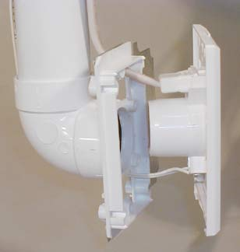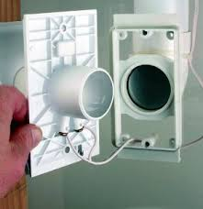

To Install the Inlet Valves:
- Remove the dust cover and dig out the ON / OFF cable
- Connect the ON / Off cable, making sure the cable is securely connected
- Mount the Inlet Valves, making sure it they are square (use a level), if the Gib fitters stoppers have cut too larger hole around the Inlet Plate you can get Plastic Mounting plates
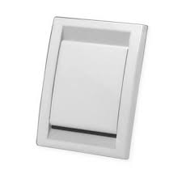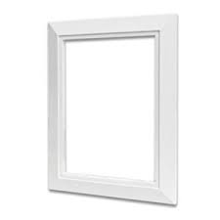
The Inlet door should open up as below so as to lessen the risk of the Valve being damaged by the hose
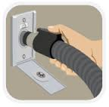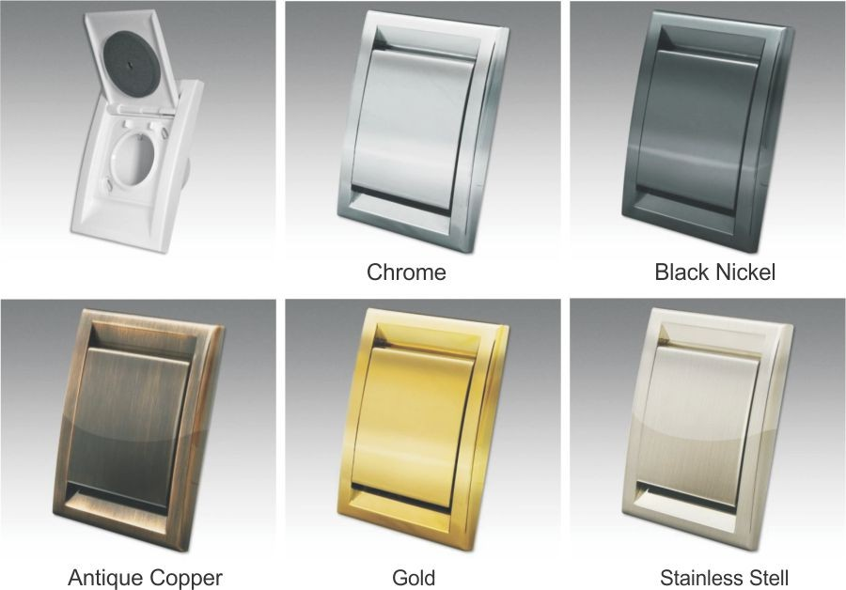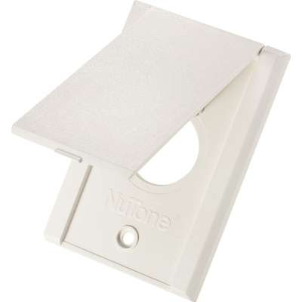
Wrong Way Correct Way Correct Way

Step 9: Test the system
Turn on the power to the Vacuum and test the suction at each inlet and at the Utility Inlet

Poor Suction
If you have poor suction:
- Check All Inlets are firmly closed
- Check that the hose is not blocked OR twisted
- Check that the Bin is on correctly
- Check No Air is escaping in any Pipe joins
- See how much suction is at the Utility Inlet on the Machine

Cleaning Tools
Usually the following Four basic tools are supplied with the unit,
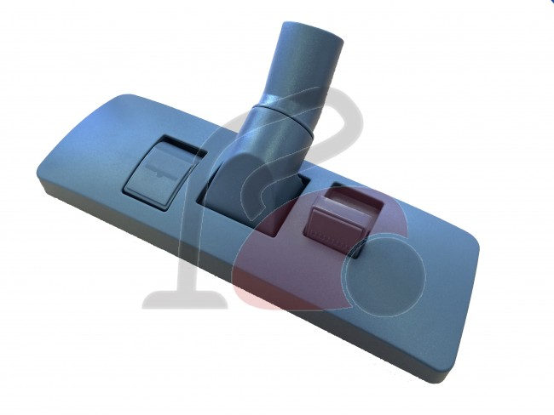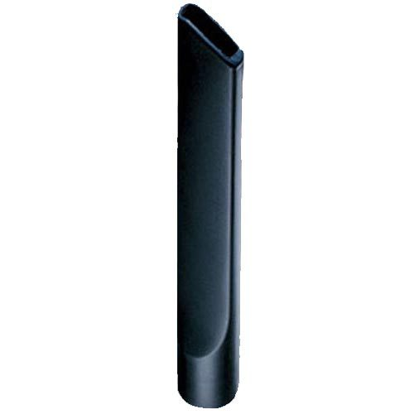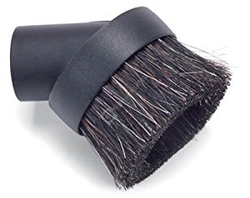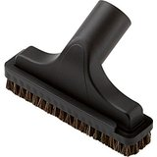
Combination Floor Tool Crevice Tool Soft Brush Hard Brush

The Combination Floor Tool has a Carpet setting with the brushes up and a Hard Floor & Tile setting with the Brushes Out, using this setting will stop scratching the floor.

If your Combination Floor Tool is hard to push on the Carpet
This is because there is not enough air flow (sometimes a problem if the carpet is glued to a concrete floor or you have a carpet with dense pile such as Rhino Carpet) The solution is to use a Floor tool with a wheel on it lift it off the carpet, Or a head with Air Holes built in, both will increase the airflow which in turn increases suction
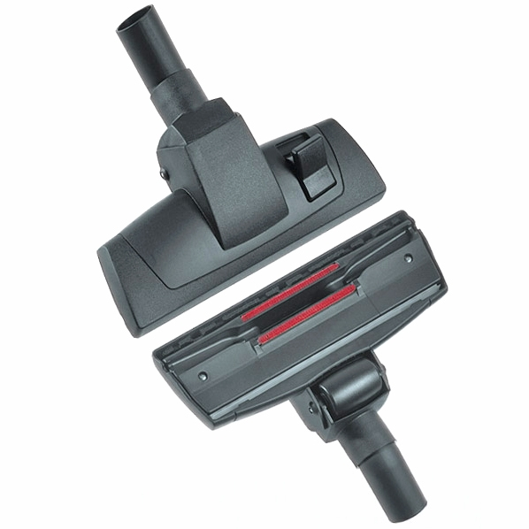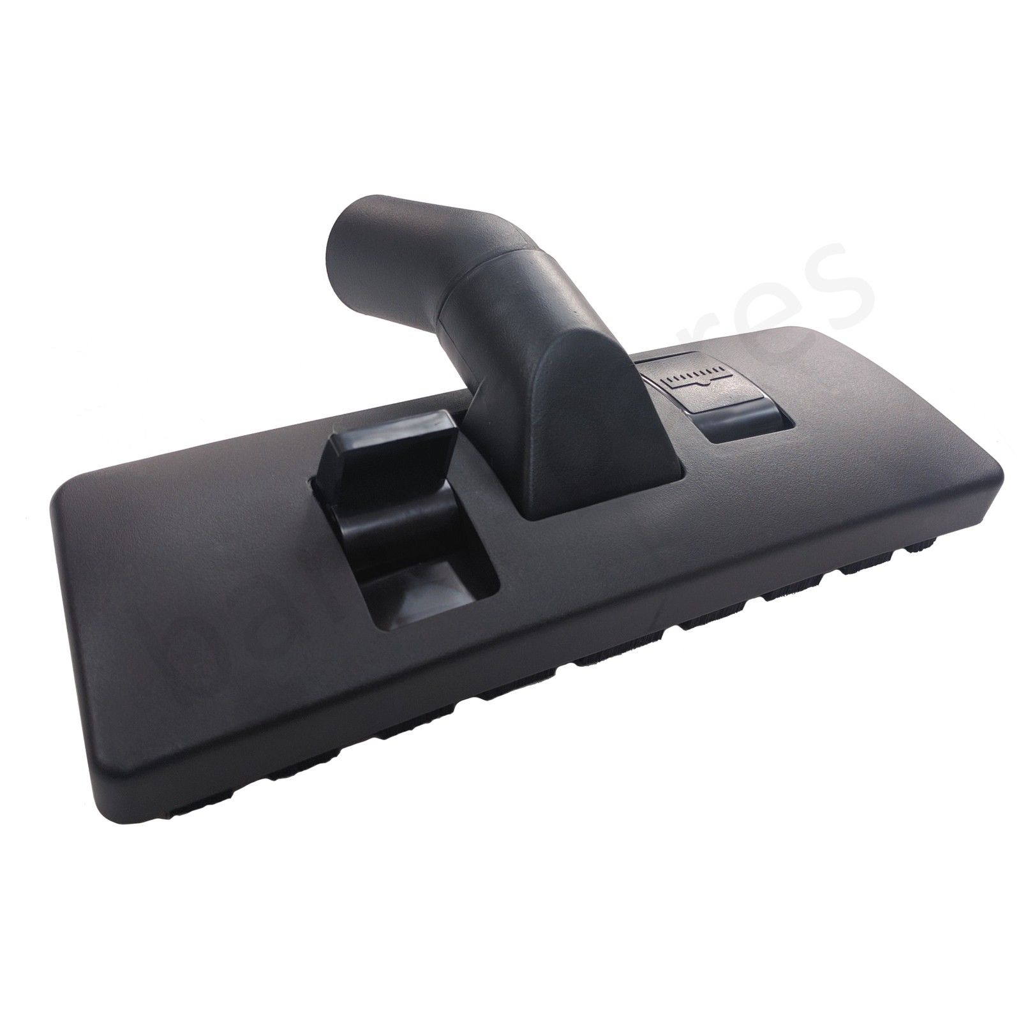
Wheeled Combination Floor Tool Combination Floor Tool with Air Holes

If the Floor Tool does not collect in ground Hair OR Dirt
Usually adding an Air Driven Powered Head will cure the problem
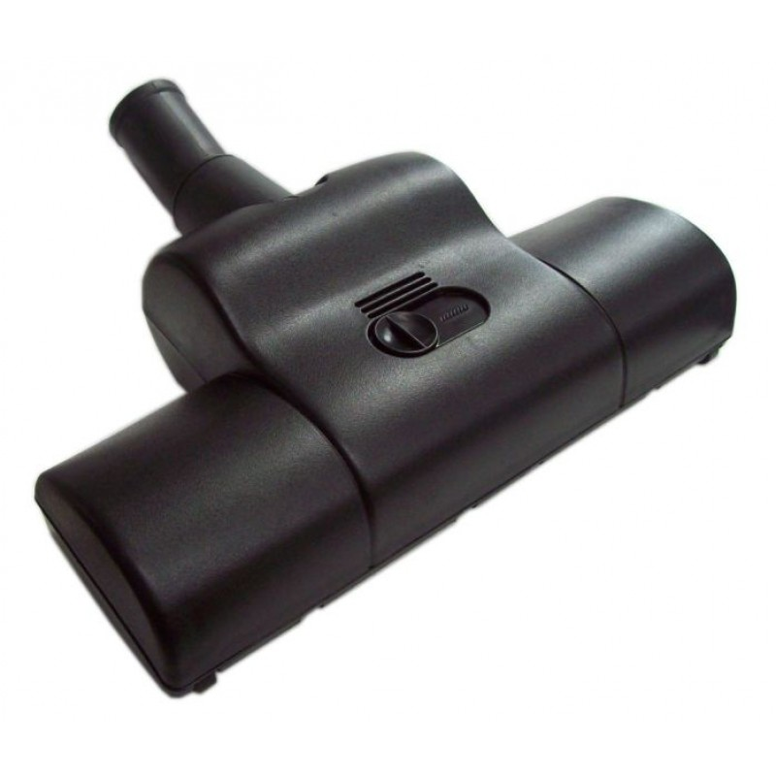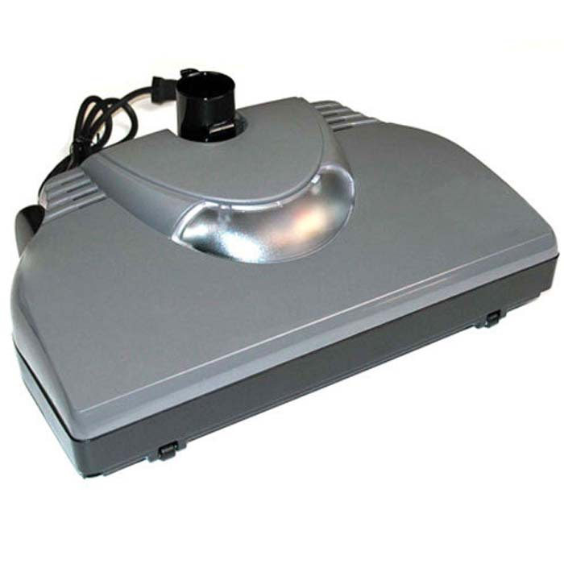
Air Powered Head Electric Powered Head

Other Floor Tools
A Mop will help Polish Hard Floors and Tiles
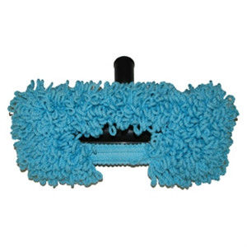
Mop

Step 10: Hang the Hose on the Hose Hanger
Hang up the hose on the Hose hanger and leave the user Manual with the Power unit

