

MAINTAINING

YOUR

CENTRAL VACUUM

SYSTEM

Central Vacuum Warehouse
Phone: 0800 723 373
www.centralvacuumwarehouse.co.nz
sales@centralvacuumwarehouse.co.nz

INTRODUCTION
This information is distributed to all owners of Central Vacuum Systems. It contains information which will be valuable to those have a Central Vacuum System. Your system is designed to last the life of your home. Like all other electrical or mechanical equipment, timely maintenance and care will ensure its trouble free operation.

Should troubles occur, don’t hesitate to seek advice from Central Vacuum Warehouse

MAINTAINING YOUR CENTRAL VACUUM
Cleaning Tools
Usually the following Four basic tools are supplied with the unit,
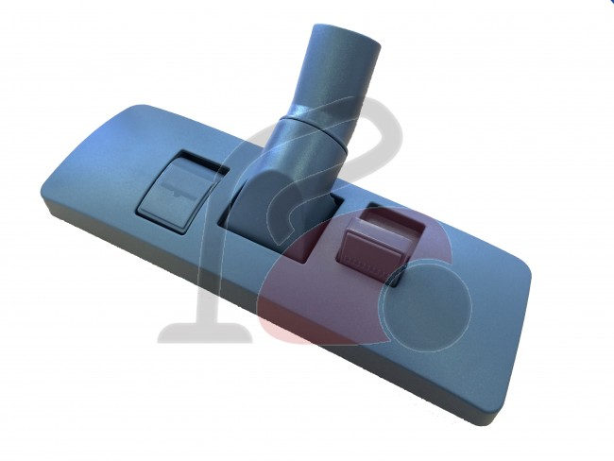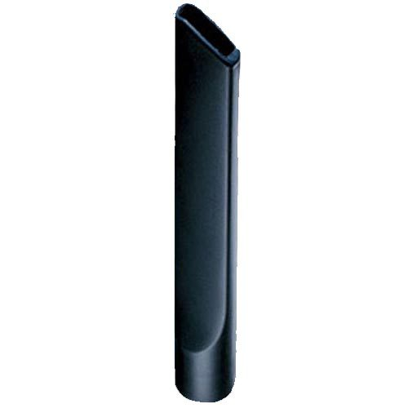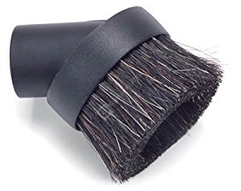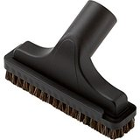
Combination Floor Tool Crevice Tool Soft Brush Hard Brush

The Combination Floor Tool has a Carpet setting with the brushes up and a Hard Floor & Tile setting with the Brushes Out, using this setting will stop scratching the floor.

If your Combination Floor Tool is hard to push on the Carpet
This is because there is not enough air flow (sometimes a problem if the carpet is glued to a concrete floor or you have a carpet with dense pile such as Rhino Carpet) The solution is to use a Floor tool with a wheel on it lift it off the carpet, Or a head with Air Holes built in, both will increase the airflow which in turn increases suction
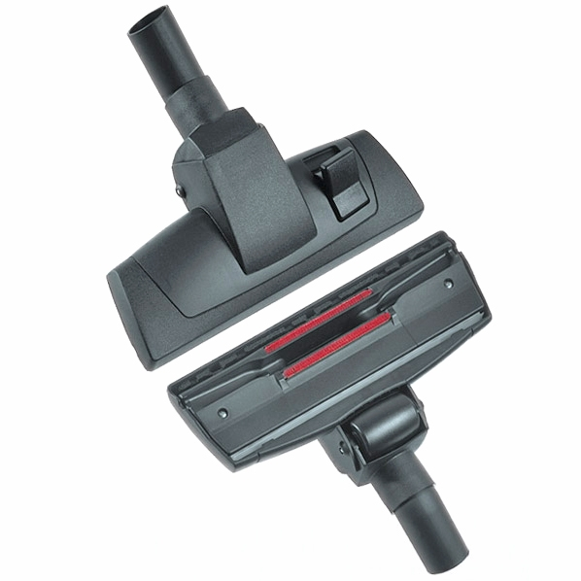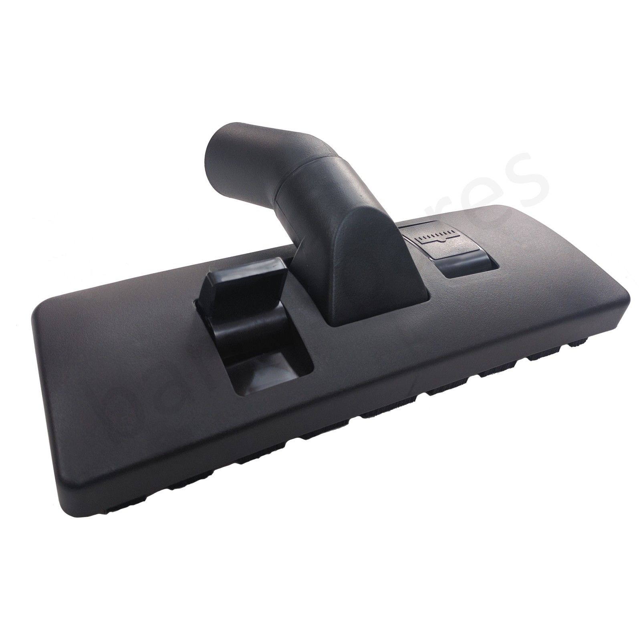
Wheeled Combination Floor Tool Combination Floor Tool with Air Holes

If the Floor Tool does not collect in ground Hair OR Dirt
Usually adding an Air Driven Powered Head will cure the problem
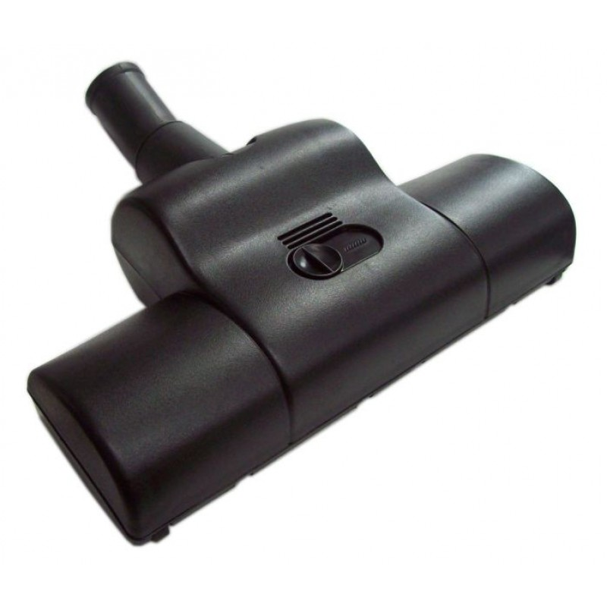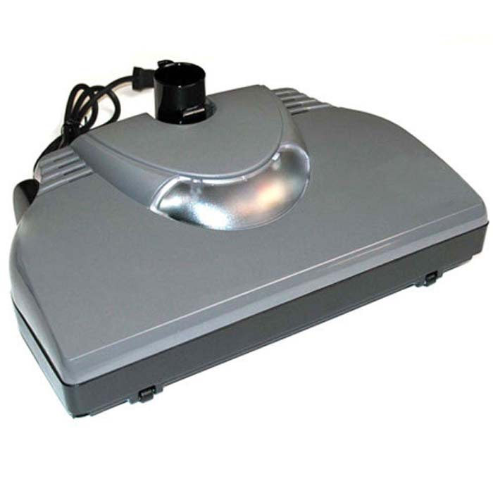
Air Powered Head Electric Powered Head
Other Floor Tools
A Mop will help Polish Hard Floors and Tiles
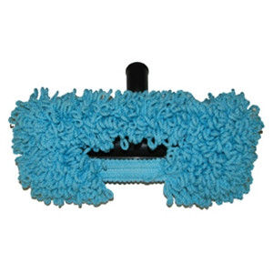
Mop

Vacuum Inlets
When opening the door of the vacuum inlet valve to insert the cleaning hose, be careful not to
distort the door by forcing it open too far or by attempting to open it when the system is operating.
The Inlet door should open up as below so as to lessen the risk of the Valve being damaged by the hose
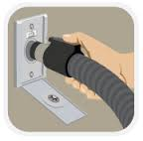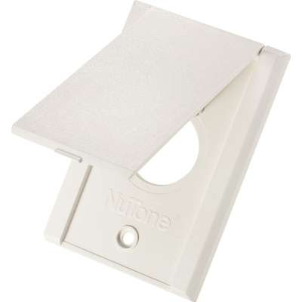
Wrong Way Correct Way Correct Way

If the power unit continues to run after the hose is removed from the Inlet open the Inlet door and check that the Pins in the Inlet have retracted
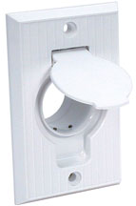

It the Power unit fails to start when the hose is inserted:
1) Move the hose in the inlet to ensure that the metal conductor part it is connecting
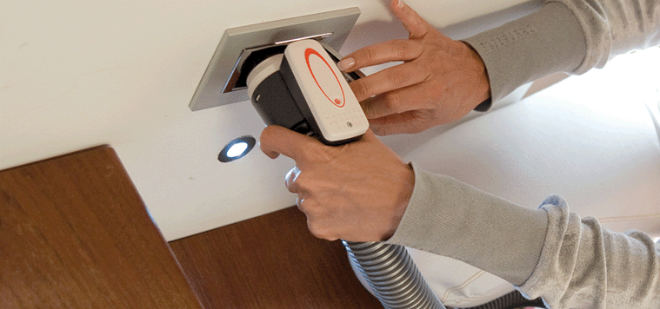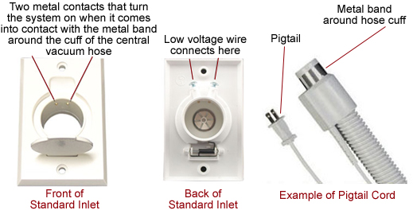

2) Check that the power has not been turned off to the Vacuum Power unit

3) If it still fails to start disconnect the electrical supply to the power unit and notify Central Vacuum Warehouse for service.

Vacuum Power Unit
Your power unit does not require any oil. The bearings in the motor are greased and sealed for life. The motor brushes must wear if the unit is to function properly. Therefore, the brushes in some power units may need replacing between 500-700 hours of use, depending on the type of motor.

Brush life is affected by humidity, altitude, temperature and the number of starts and stops so
there is a wide spread in the life of the motor brushes. In average home use, the life
of your motor brushes should be approximately eight years. The cost of replacing your motor
brushes is not appreciable, but damage done to your motor through not replacing the brushes
before they are worn, is considerable. You should take advice from your local dealer on
brush wear and maintenance.

If your Motor unit is located outside it must be protected from rain.

Replacing the Filter Bags in Bagged Central Vacuums
The mass of dirt/dust picked up by the vacuum system is deposited in the disposable bag. It is
important that the bag is replaced when the dirt level is nearing the top of the bag. The efficiency
of the vacuum suction is an indication of the time to replace the bag. The machine will function
efficiently until the bag is nearly full. Damage to the motor is inevitable if the bag overfills and
bursts. It only takes a few moments to check the bag and about a minute to change it!
It is not advisable to re-use the paper filter bag.

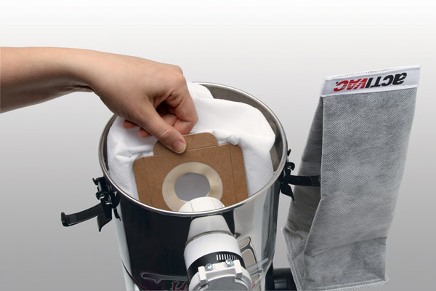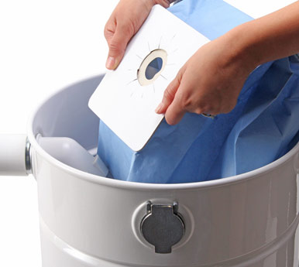

The Bag should be replaced when it is half full, usually every 3 months or so OR if you notice any decrease in suction

Make sure that when replacing the bag that it fits securely over the Inlet pipe in the Machine

Caution: Always replace used bags with a new bag as reusing bags will shorten motor life.
Do not leave your Vacuum available for builders to use to clean up your new home. We recommend that you take the hose away with you if the Vacuum is installed before you move into your home.

Ordering New Vacuum Bags.
Order online at our website OR ring our 0800 723 373 toll free number
We will courier OR post the bags you require out to you.

Cleaning the Filter in Bagless Central Vacuums
About every 3 months OR if the suction seems to decrease then empty the canister if a Bagless type and clean the filter

Regular cleaning of the Filter will increase your Vacuum Life

While the information below is for a Hills Central Vacuums which is the most common model we sell, the same rules apply for all Vacuums

Before starting unplug the Vacuum Power Unit

Be careful when taking the Bin off from the Motor part; DO NOT DROP it as you can damage or Break the Plastic Bin
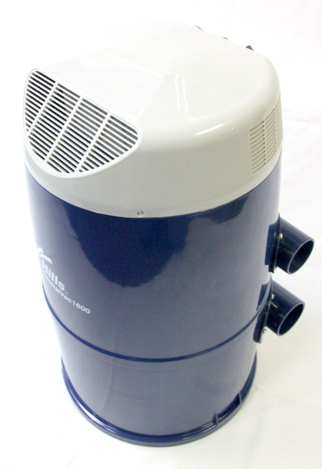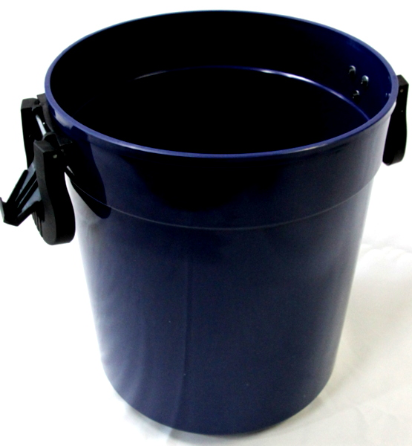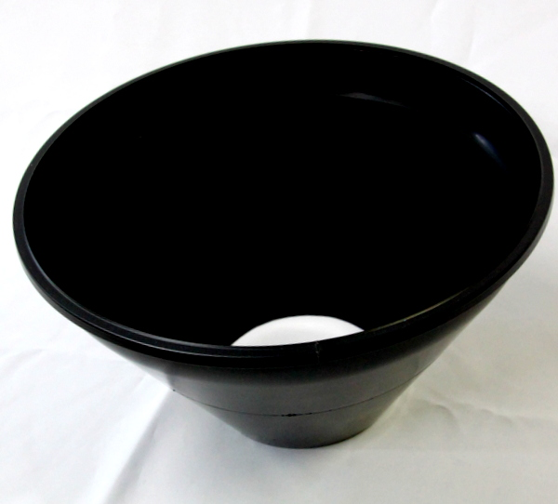

Once you have the Bin off empty it in a Rubbish Bin OR Dumpster

Then unscrew screw the clamp holding the Filter in:
The filter is held in by a clamp that looks like this
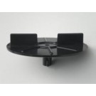
Hills Vacuums under 10-12 years old will have a filter that looks like this:
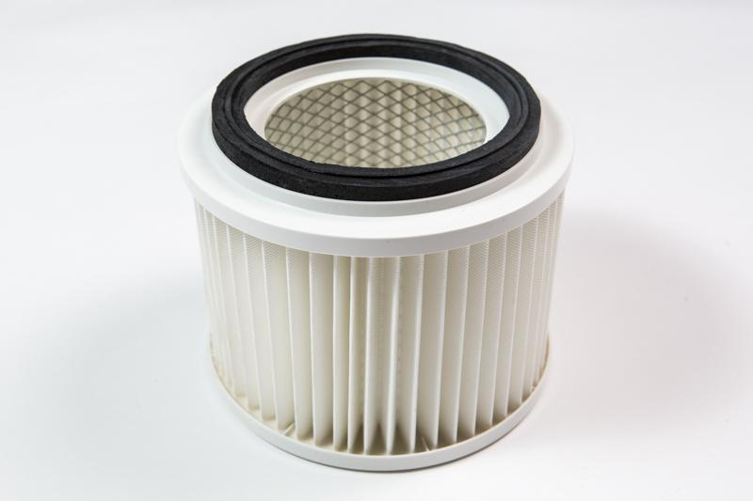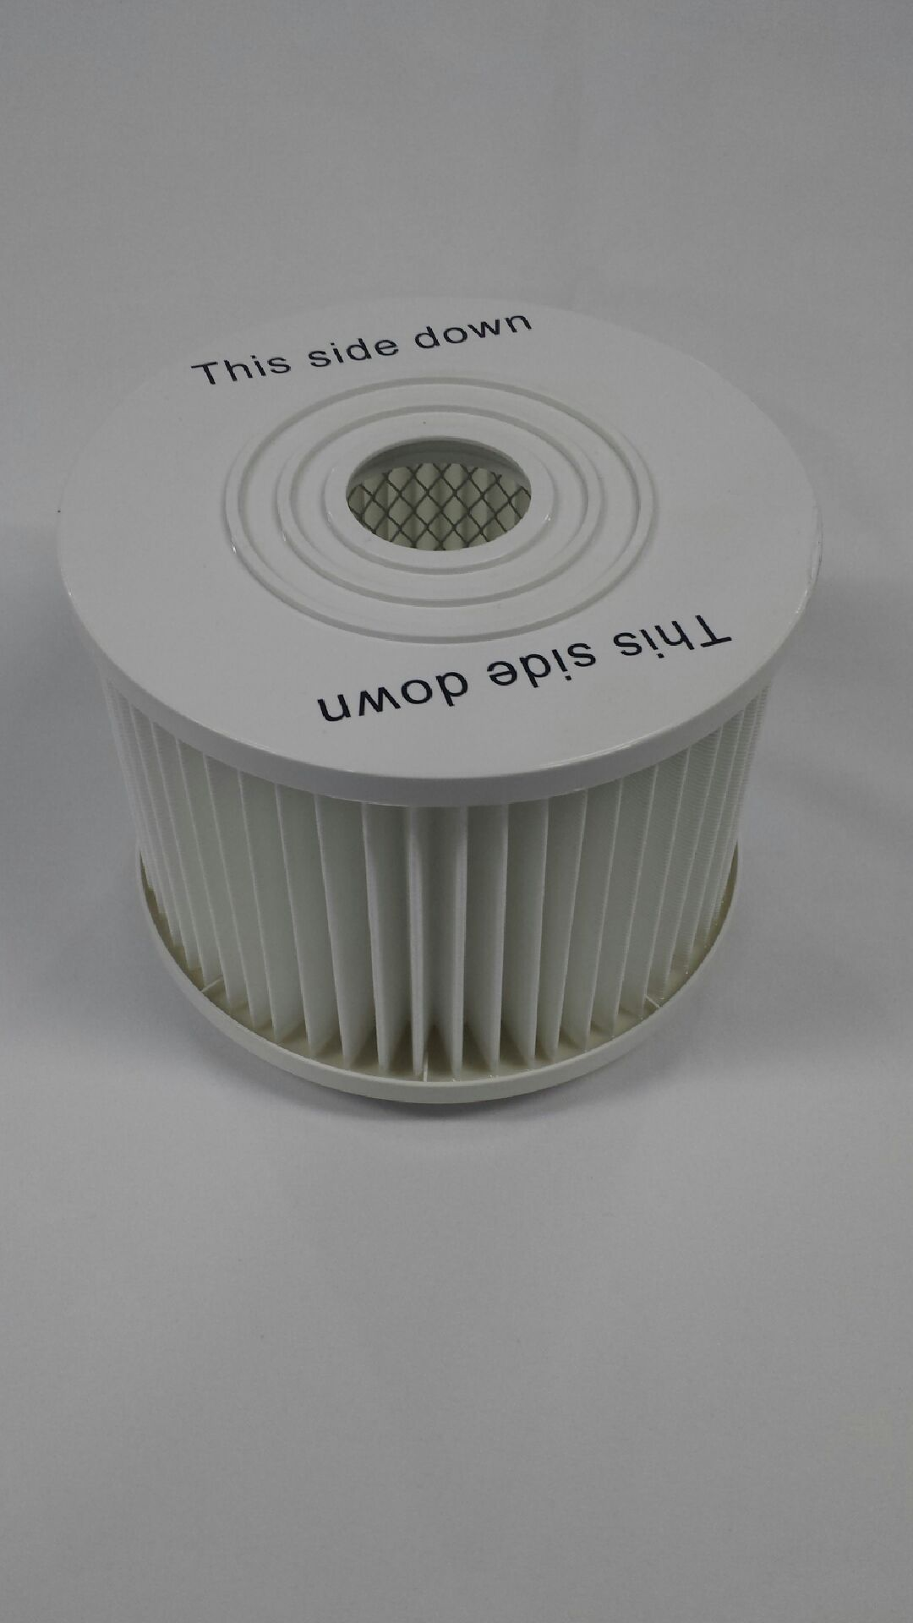

Hills Vacuums over 10-12 years old will have a filter that looks like this:
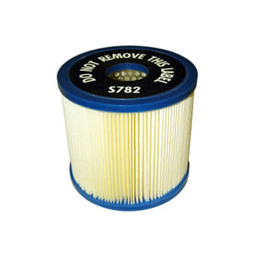
To Clean the Filter:
When cleaning the Filter Dust will go everywhere,
A good idea is to wear old clothes and take the filter out to a Plastic Rubbish Bin OR Dumpster
Tap the filter against the side of the Bin OR Dumpster till all the dust comes out
Brush the filter on both sides to remove any caked on dust
Remove any dust from inside the Filter Leaves by brushing OR scratching it off with a blunt item so as not to damage the filter.

If there are any holes in the Filter replace it

Before replacing the Filter in the Machine put your hand up inside to check that there is no Dust OR Rubbish lodged inside

Then replace the Filter and tighten the lock Clamp
Then Replace the Bin, making sure that the Rubber seal is around the outside of the cone

The Cone always faces down into the bin

Vacuums with Membrane Filters
If the Vacuum has a Membrane filter it will be up inside the Canister and will have a pull Tag on it, they can be difficult to remove and even more difficult to get back in Place
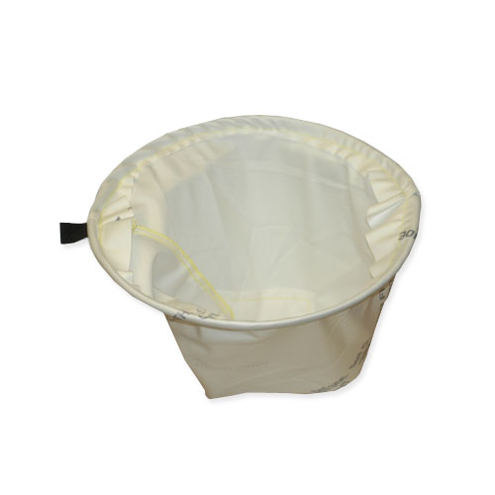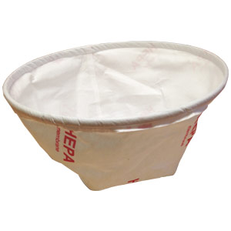
After cleaning it then be carefull to get it back in place firmly in the Vacuum Bin

Poor Suction
If you have poor suction after cleaning:
- Check All Inlets are firmly closed
- Check that the hose is not blocked OR twisted
- Check that the Bin is on correctly

If you See OR Smell Smoke when Vacuuming
Stop the Vacuum Immediately, the Motor will be damaged and need replacing

Other Tips
Never use or let builders use the vacuum to suck up concrete dust especially in new homes as this is the most abrasive material possible.

If you are vacuuming New Carpet clean the Filter OR empty the Bag more frequently for the first month

An extra-long chrome wand is available for taller persons on request.

