

PIPE OUT

INSTRUCTIONS

For

CENTRAL VACUUM

SYSTEMS

Central Vacuum Warehouse
Phone: 0800 550 553
www.centralvacuumwarehouse.co.nz
sales@centralvacuumwarehouse.co.nz

INTRODUCTION

This information is distributed to all buyers of Central Vacuum Systems. It contains information which will be valuable to those who install their own systems and also to those who have the installation performed by installers.

Your system is designed to last the life of your home. Like all other electrical or mechanical equipment, timely maintenance and care will ensure its trouble free operation.

Should troubles occur, don’t hesitate to seek advice from Central Vacuum Warehouse

Note: Keep all of your off-cuts from the pipe-out and any spare fittings for the Vacuum Fit-Off

THE INSTALLATION OF CENTRAL VACUUM SYSTEMS

Section A: Over View
A Central Vacuum System has Vacuum Inlets located throughout a home so a 10 meter hose will cover all areas of the house and once plugged into an Inlet Valve start a Vacuum Power Unit.

Each Inlet Valve is connected to the Power Unit using a 50MM (2”) diameter vacuum pipe.

Each Inlet Valve has an On / Off cable connected to it which runs back to the Power Unit, this cable enables the Power Unit to start automatically when the Vacuum hose is plugged into an Inlet.

For single level homes the pipe duct line will usually be overhead in the ceiling, but can be under the floor, in the basement, in the crawl space under the house, or under the slab, or a combination of the above. If under the slab, installation will have to commence before the slab is poured and the vacuum pipe must be installed inside a plumbing waste pipe. All cables in or under concrete must be run in conduit; this includes cables in Concrete walls. Pipes in concrete walls should be wrapped in plumbers felt.
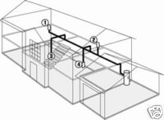
For multiple level homes the pipe duct line will usually be a combination of being in the cavity between the floors, and in the roof with down pipes from the roof to the lower levels.
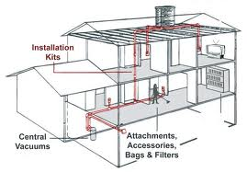
It is usual to run a central ducting line with branch lines running to the inlets, using 90° Sweep Elbows and 45° Elbows and 90° Tee Joiners. The 90° Sweep Elbows and 45° Elbows are used to reduce friction losses and prevent blockages in the pipe runs where turns are required. The 90° tight elbows are only to be used at the connection to the inlet valves, (these elbows are called blockage eliminators as anything that passes through a tight elbow will easily pass around a sweep 90º elbow. Obstructions are best caught before the first inlet). These elbows also fit comfortably within the 100mm wall framing for wall mounting.

Special 90º elbows are available for 75mm frames.

It is better to have more inlets than not enough if there is a question over the number of inlet points required.

While Inlets can be mounted at any height on a wall we recommend that you install them at the same height as the Electrical Plugs (measure the distance of the plugs to check but they are often 250m to 300mm from the floor). Consider the placement of furniture, convenience of inlet and aesthetics when finally selecting the positioning of inlets on the wall. Try to site the Inlets close to doors and in hallways if possible, also be aware of the framework above the potential Inlet site; you will need enough space to fit Top Plate Stiffeners if these are being used.

The vacuum lines may be run under the floor, in the roof between floors or in the roof.
The efficiency of systems is greater when dust runs downwards rather than being lifted overhead.

Where there are two or more stories, confirm that the piping can be run back to the unit with
a satisfactory connecting line between the floors. Installation procedures are described later.
Do not lift dust over two stories in height.
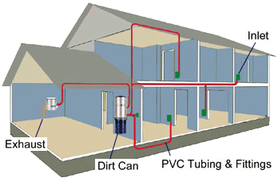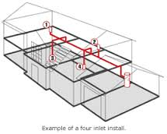

Section B: Building the System
Before drilling any holes check with the builder to make sure that you are not drilling through load
Bearing Walls and that any holes you drill comply with the building code, (Top Plate Stiffeners are usually required when drilling through Top Plates) and he is happy with the location of the holes you propose to drill.

Make the necessary penetrations in the walls/floor framing at the selected inlet points and at points
where the pipes are to be located through framing. DO NOT drill holes through studs.

If drilling through load bearing joists see recommendation that follow.

Always consult with the Builder before you start drilling holes.

Before Drilling any 54 OR 57MM Holes
Drill test holes if in doubt to make sure you have enough space for the pipe and any bends.
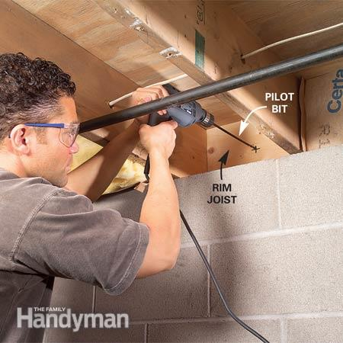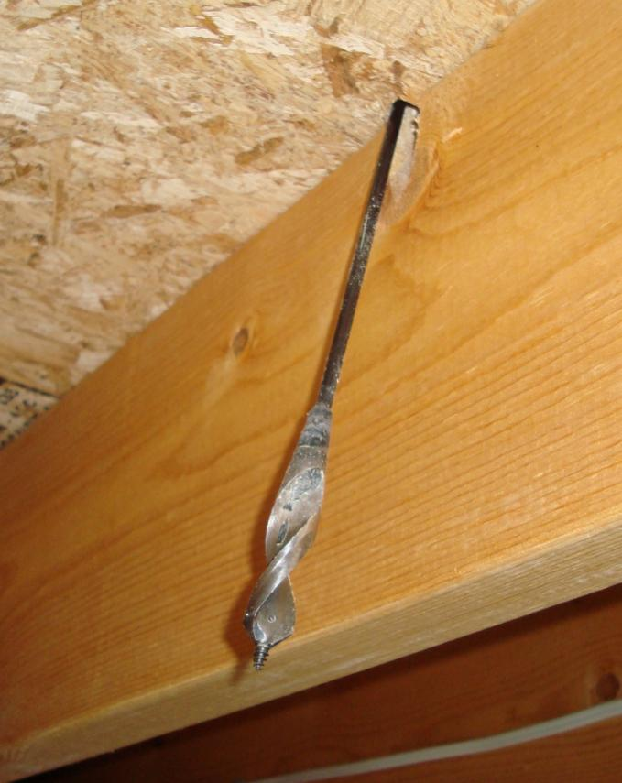
Correct Location Wrong Location

Are Top Plate Stiffeners required?
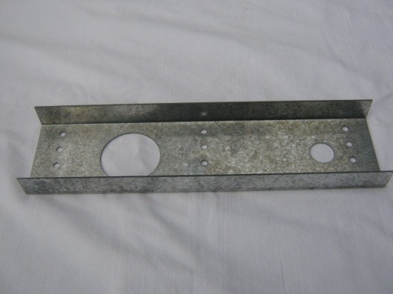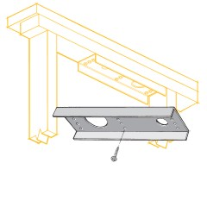
Most Council’s require that Top Plate Stiffeners are installed for all holes larger than 35MM that are Drilled through the Top Plate. The Builder will be able to guide you on this.

If they are required bear this in mind when deciding on the Power Unit and Inlet locations, ideally
you are not drilling through major load bearing areas.

The Top Plate Stiffener bolts are 5MM and require a 4 MM hole to be drilled for each, the bolt head
is usually 12 MM and you need a ratchet OR a 12 MM fitting for your power drill. If you are using Top Plate Stiffeners measure your Top Plate Stiffener before drilling any holes to make sure it fits between the Studs.

Some Councils are happy that you use “L” shaped strengtheners which are cheaper that the Top
Plate Stiffeners
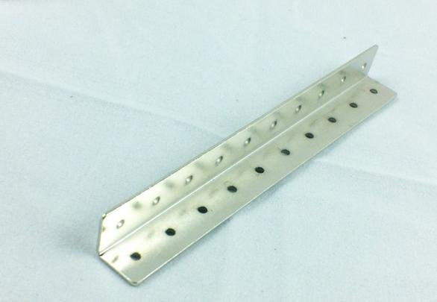

Drilling through Joists
Before drilling through Joists talk to the Builder about what you are planning to do.

We recommend that:
- You drill in the middle of the Joist and near the end of the Joist where it connects to a load Bearer
- You use Joist Strengthener Brackets, OR sometimes we can use Gang Nails as strengtheners nailed below the hole in the Joist, usually 25MM x 150MM, Or if a Double Joist 50MM x 150MM
- You drill the Hole near a Support Beam, not in the middle of the Joist Lengthwise
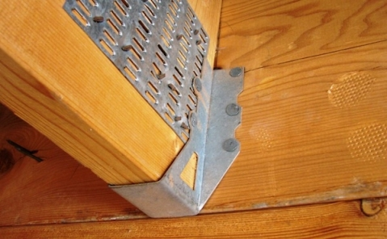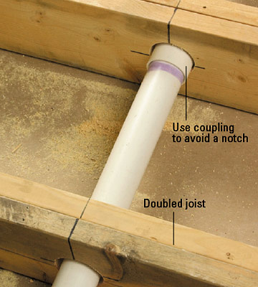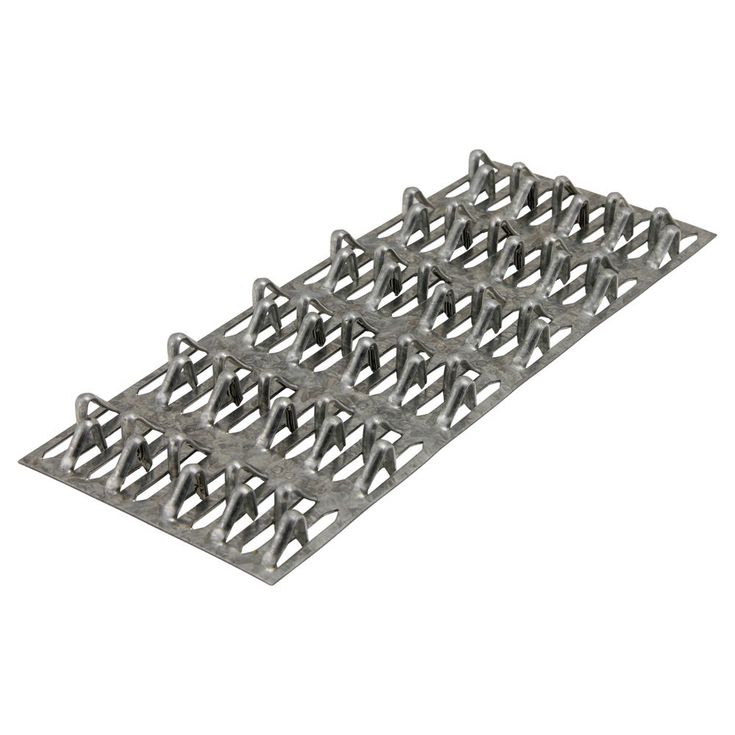
Multiple Inlets from 1 down Pipe
I try to back to back Inlets if at all possible, if you have an inlet in the Hall this may back onto the lounge, saves on pipe, labour and a Top Plate Stiffener.

Health & Safety
Talk to the Builder about any Health and Safety requirements they have, and make yourself familiar with any potential hazards.

Section C: Installing the System

Step 1 - Decide on the location of the Central Vacuum Power Unit
The most ideal location and the most common for the Central Vacuum power unit is in the garage, hopefully on the wall adjoining the house, this will save on pipework. A good location is in the corner of the garage by the garage door.
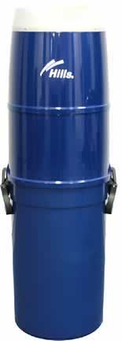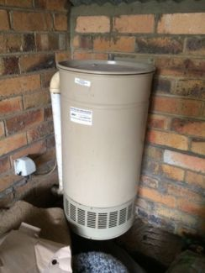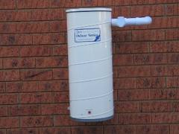

The power unit requires 240V near it, if no power point is close then organise with the electrician to install one

The power unit also has a Utility Inlet on it to Vacuum in the garage or to vacuum vehicles, measure the distance from the unit to the further most point in the garage to help decide the best location.
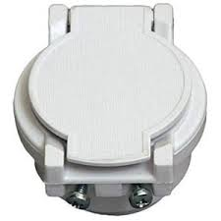
Other locations include storerooms and, if space allows, under the house. The Central Vacuum power Unit should NOT be mounted in areas having excess heat. Closet areas and other ‘closed’ areas can be considered, but they have to be well ventilated. If installed in a closed area we recommend exhausting the unit into the roof space or under the house. If this is done an elbow should be used on the exhaust to stop litter falling down it. Louvres or space below and above units mounted in cupboards are required to enable air to circulate and exhaust freely.

Units mounted on outside walls require protection from rain and excess heat. We can supply metal canopies for outside mounting. The canopies protect the motors from rain and allow good ventilation.

Noise is a factor when siting the power units. Whilst there is little noise within the house, the noise from poorly sited units may be offensive to neighbours. To assist with noise protection, mufflers are available and should be used they do reduce the noise level.

Care should be taken if exhausting the motor outside. This can cause staining of block work and the noise of the air through the outside vent can annoy neighbours.

The Down Pipe to the Power Unit must be at least 275mm from the Stud you intend to mount the Power Unit on

When deciding on the Location of the Power Unit install it so some one 175CM tall can operate it

Step 2 – Decide on the location of the Inlets
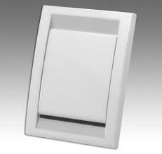
Hallways are good locations as it may be possible to reach two, three or even four rooms from
one location. Hallways are rarely obstructed by furniture placement. When siting inlets a good
position is by doors, always install on the opening side, consider the swing of doors as an inlet behind a door will cut down coverage to some areas by up to 1.5 meters as the hose must be pulled around the door.

Inlets near the base or bottom of a stairway permit easy and convenient cleaning of
stairs from the bottom up. All inlets should be at least 150mm (6”) from any opening
or corner to ensure that they do not interfere with architraves or other fittings.
Ensure that vacuum pipes can be run to each inlet point location.

Do not install Inlets in areas where they will reduce the aesthetic appeal, for example in Entry Halls.

Make sure that when measuring out for Inlet Valves you have accurate measurements
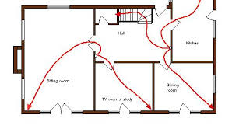
(i) Inlet 1
Select the inlet point furthest from the motor unit first. Go to the further most room and measure 9 -10 meters back towards the power unit location from the further most point, this will be the location of the first inlet (usually you will be in the hallway apart from very large rooms) Check that the area can be covered from that point (our hoses are 10 meters long so by measuring 9 meters you have some tolerance to get around furniture, and as well you have the wand which can reach one further meter, and if the client is using a Switched Head Hose then these are 12 meters) Be sure to take into account positioning of furniture and movement around doors, etc.

(ii) Inlet 2
Select the location of inlet 2. Measure 9 -10 meters back from the area covered by the first inlet back towards the power unit location, this area will from the furtherest point, this will be the location of the first inlet (usually you will be in the hallway apart from in very large rooms)

(iii) Remaining Inlets
Now select the locations of the remaining Inlets following the procedure above

(iv) Back to Back Inlets
Inlet plates in the same wall cavity help save on pipework, in this situation install 1 inlet on each side of the cavity space

(v) Final Location Decision
Once you made the measurements spread the Inlets out so they fit in the best way and mark their locations.

(vi) Multi Level Buildings
The pipe out in a multi level building may look like this

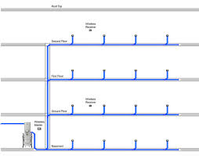

Step 3 – Install the Inlet Mounting Plates

(a) Fix to the stud (most common)
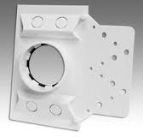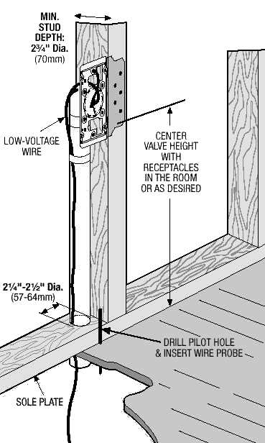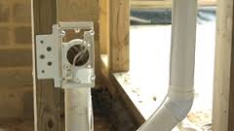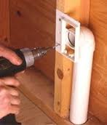
(i) Inlet Height
Install the Inlets at the same height from the floor as the Power points.

(ii) We usually supply mounting plates as pictured below, if you are using this type carefully bend the mounting area of the Face Plate at a Right angle and nail to the side of the stud or Chisel out a little wood off the Stud so that when you nail the Face Plate onto the stud it is flush with the stud. The Inlet Plate is marked “Top” with an arrow, install the correct way up.
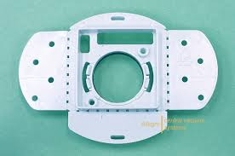

If you are piping out steel framed home then you must use this type of Inlet, in which case you will have to drill a Screw hole and screw the Inlet Plate to the Steel frame

(b) Fix to the floor (Try not to use these)
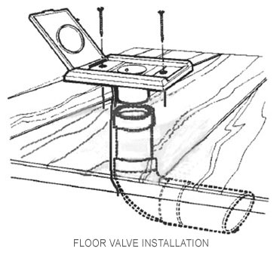

(i) Inlet Position
Install the Inlets in an area that will not be walked on.

(ii) Installation
Chisel out a little wood off the Stud so that when you nail the Face Plate onto the stud it is flush with the stud.

Equipment Required
Wooden Framing: Mounting Plates and Nails
Steel Framing: Mounting Plates, Drill bit and screws

Step 4 – Drill 54MM holes for the pipe down to the Power Unit
Measure the hole centers to be drilled in the Top Plate and in the cross dwangs down to the Location of the Power Unit, making sure they are vertical. Do not drill them less than 100MM from the stud OR you will hit nails and you won’t be able to fit Top Plate Stiffeners.

Check that there are NO electrical cables in the way, especially above the Top Plate. If there are tie them back so the drill does not hit them.

The mounting bracket that the Central Vacuum Power unit sits on needs to be screwed to a stud and if any cross members to a Dwang

For a Hills 1600 Vacuum the mounting bracket is an upside down T with 2 screw holes on the T op of the T and 2 screw holes on the T part.
The second Top hole should be in a horizontal line with the middle of the Inlet pipe coming out from the wall and be 275MM from it.
The holes on the bottom T are 75MM from the Second top hole
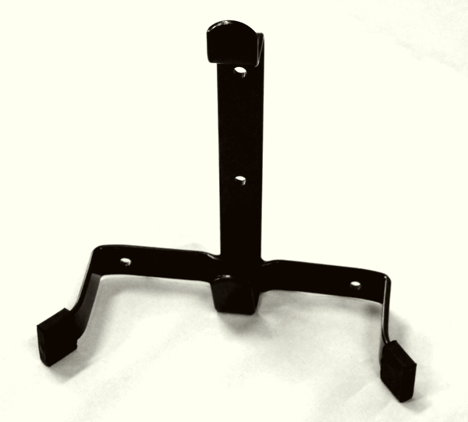
Equipment Required: Drill and 54MM OR 57 Drill Bit

Step 5 – Drill 54MM OR 57MM holes for the pipe down to each Inlet
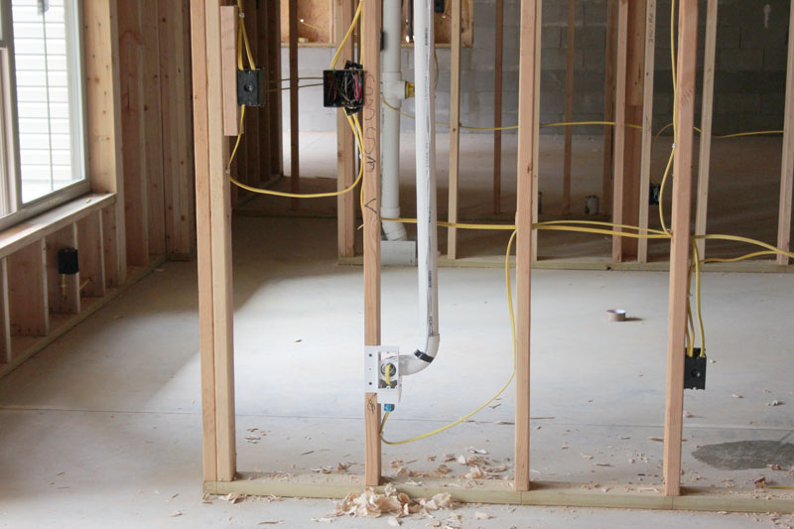

Measure the hole centers to be drilled in the Top Plate and in the two cross dwangs down to the Inlet, making sure they are vertical. Do not drill them less than 100MM from the stud Or you will hit nails and you won’t be able to fit Top Plate Stiffeners.
Check that there are NO electrical cables in the way, especially above the Top Plate. If there are tie them back so the drill does not hit them.

Equipment Required:
Wooden Framing: Drill and 54 OR 57MM drill Bit
We suggest a 57MM Drill bit is best as you have to be less Precise in hole placement
l 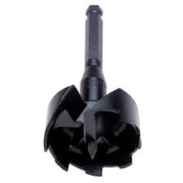
Steel Framing: Drill and 54 OR 57MM Hole Saw for the Vacuum Pipe and 20MM Hole Saw for the cable

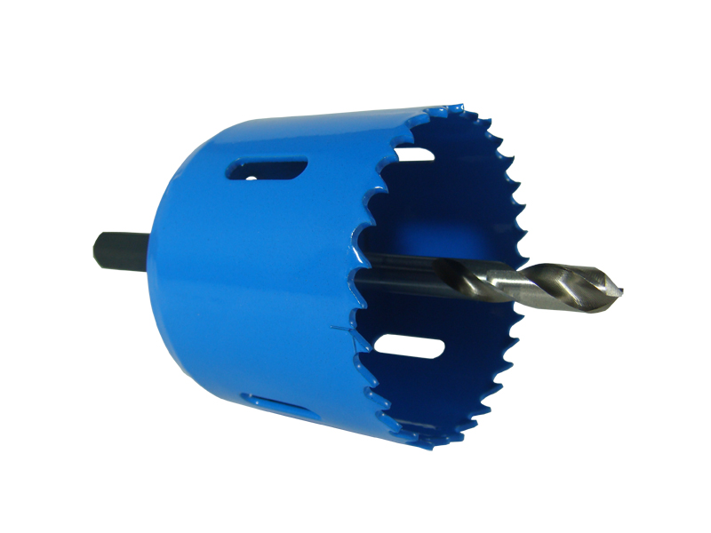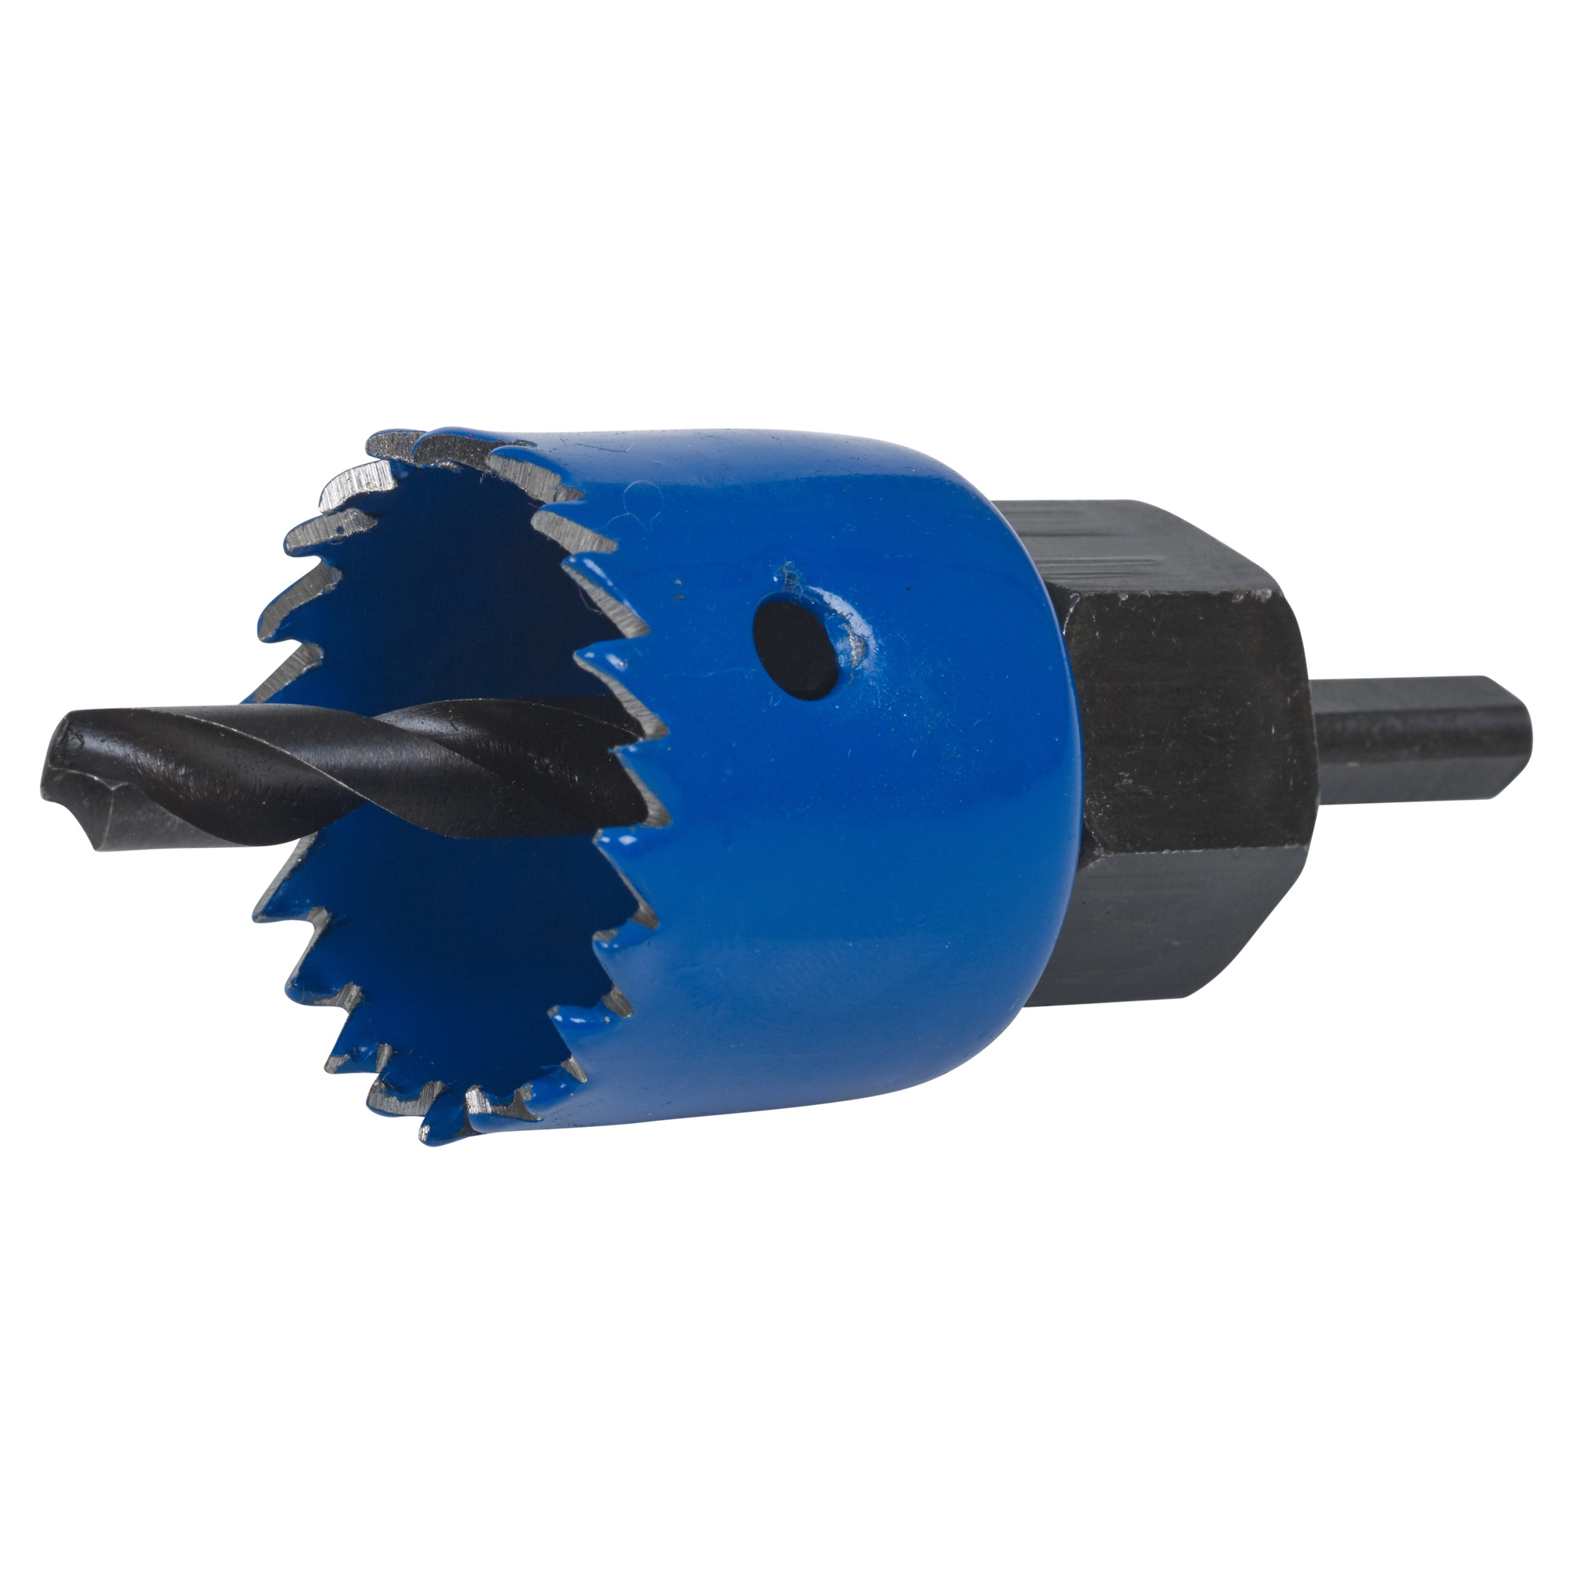

Step 6 – Drill holes for the on / off cable down to each Inlet and to the Power Unit

Drill separate holes for the cable, for Wooden Frames drill 6, 7 or 8MM holes beside the Vacuum pipe, and for Steel Framed homes drill 20MM holes, then insert a Grommet in the hole to stop the cable chaffing over time.
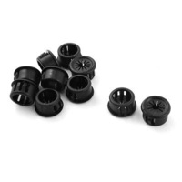
DO NOT run in the same hole as the Vacuum pipe as over time with friction the cable will wear and you will get faults.

Equipment Required: Wooden Framed Houses Drill and 6MM Drill Bit
Steel Framed Houses: Drill, 20M Hole Saw and Grommets

Step 7 – Run The Vacuum Pipe from each Inlet back to the Power unit

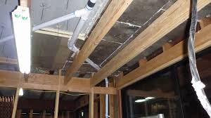

(i) Measure and cut the pipe lengths required to build the branch and central ducting pipes. Debur
all of the pipe ends inside and out to eliminate any chance of dust/dirt build-up at the joints. Join the pipes together using couplings; apply glue to inside fitting joints only. Use the sweep bends, elbows and tees along all duct lines. Ensure all bends are in the direction of airflow to the unit.

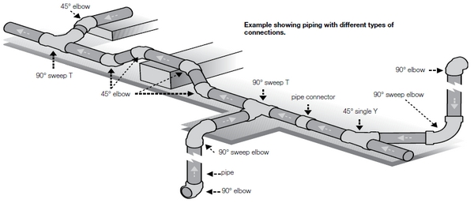

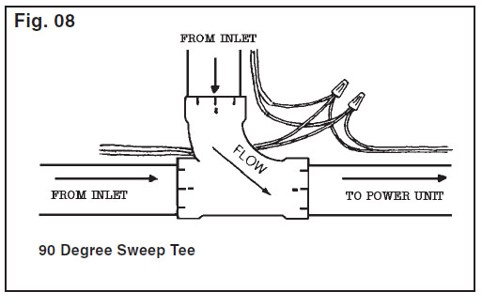

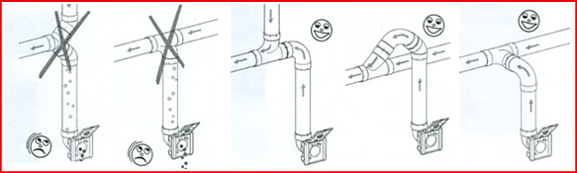

If you need to bend the pipe around frames, joists etc then you can use a 45 degree bend OR a 45 Spigot Elbow
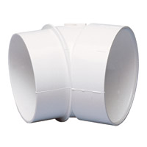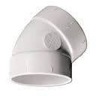

The 90°sharp elbows are ONLY used as connectors to the wall mounting plates.
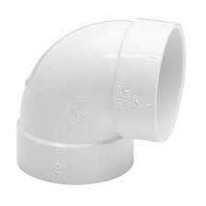
(i) At the furtherest Inlet install the Vacuum Pipe from the Roof cavity OR ceiling cavity down through at least the first Dwang and glue a sweep 90 to the top of the pipe in the Roof Cavity OR Ceiling Cavity

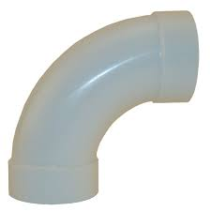
(ii) Then run the pipe back to the next inlet, joining it with pipe joiners and so on and once all inlets have been connected onto the Power unit, gluing it as you go, Glue the pipe NOT the Fitting
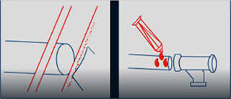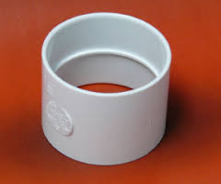
If you have to branch off the main pipe for a inlet use a Sweep Tee
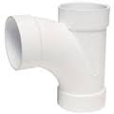
If you have to go around framing use or other obstacles use 45 or 90 Elbows
If you have a three way bend you can use 90 Elbow and a sweep Tee or a three way Tee
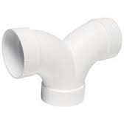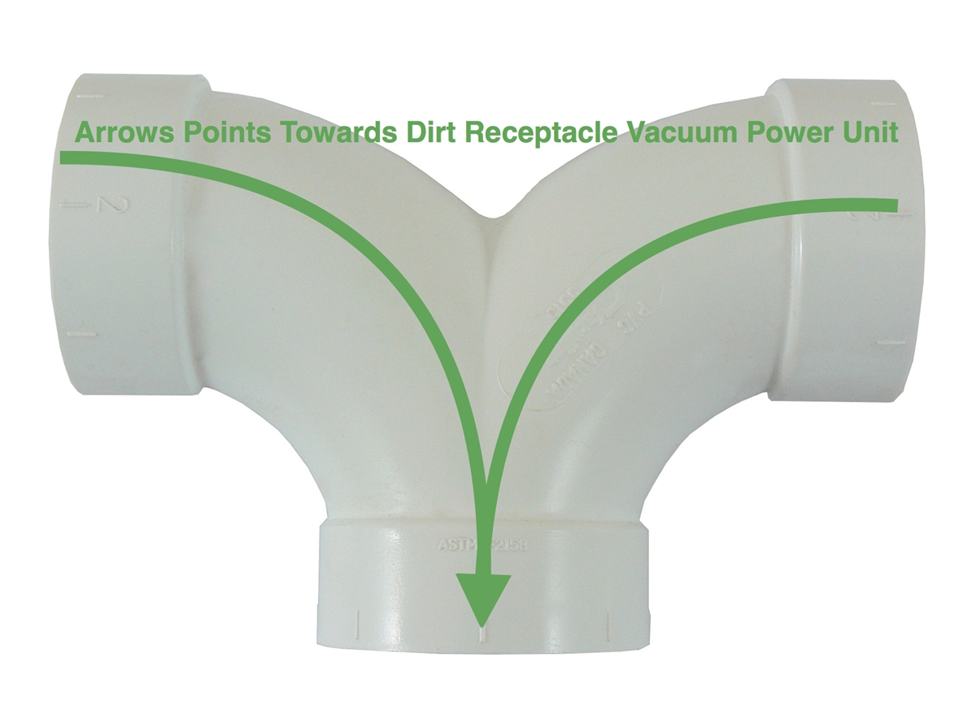
(iii) At the Power Unit
Insert a 90 Degree Sweep bend onto the end of the pipe, usually just below the first Dwang

(iv) Once the Pipe run is complete:
Wedge the pipe with wooden wedges on each down run in every second dwang and on every 3 OR so Joists if running between floors so it cannot vibrate
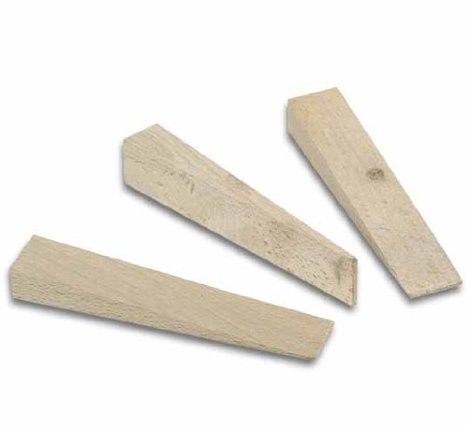
Equipment Required
Wooden Wedges
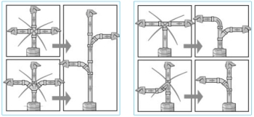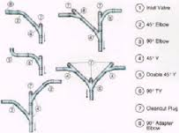

Step 8 – Connect The Mounting Plates to the down pipe
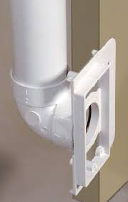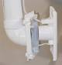

Use a tight 90 then, a length of 50MM pipe and a 45 Elbow to the downpipe OR a tight 90. A length of pipe and a Sweep 90
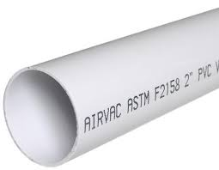

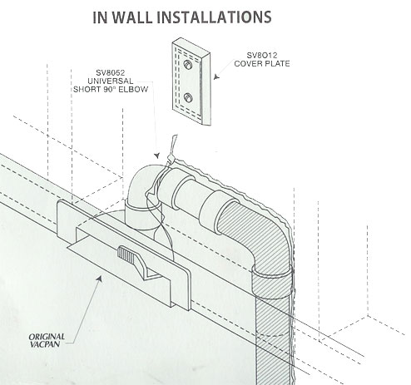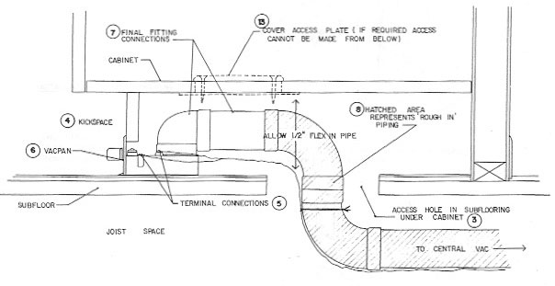

Step 9 – Run a minimum of a twin cable from the Power Unit to each Inlet
We usually supply Cat5e cable with DIY systems which has 4 pairs of cables; we suggest you twist the Orange and Orange/White pair together and use for one wire and the Blue and Blue/White pair together for the other wire.

The system operates on a Normally Open circuit (NO) so the cable is run to the first Inlet then on to the next Inlet and so on, terminating at the last inlet. At each Inlet Pull the cables through the cable hole in the inlet plate and push it back up the pipe.

Run the Vacuum ON / OFF cable in the holes you have drilled for the cable. Tape the cable to behind the inlet so it cannot move and can be easily reached if required when the face plates are attached later.

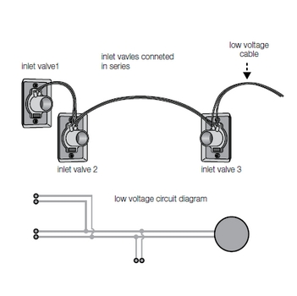
Step 10 – Taping the Cable and fitting the Pipe Saddles
Fit the pipe saddles over the Vacuum pipe to stop the pipe flexing, use a saddle each side of bends and corners and every meter or two along the pipe.

Tape the cable to the Vacuum pipe every meter or less so it is tight and not hanging down in the way, DO NOT leave excess cable hanging loose or screw the Inlets plates onto the mounting plates as in the third picture

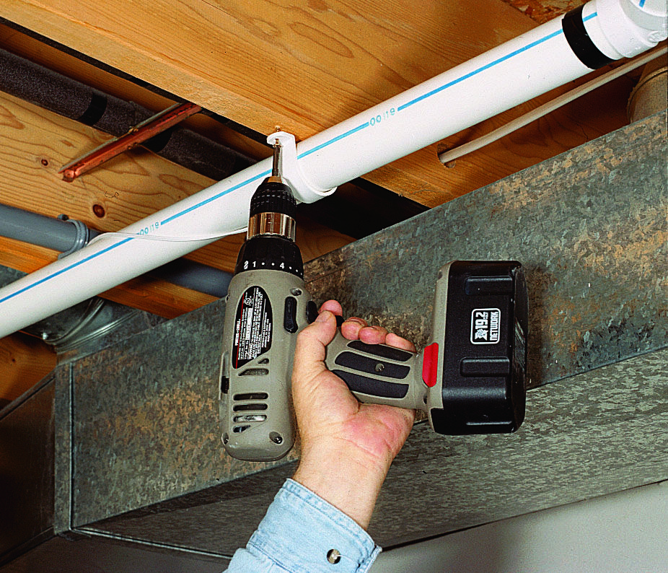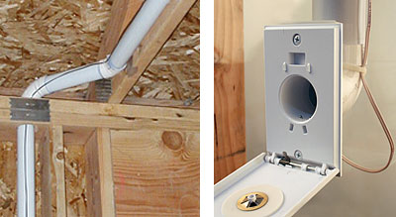

Nail Pipe Saddles over the pipe to hold the pipe in place on either side of each bend and every 2.25 meters on straight runs
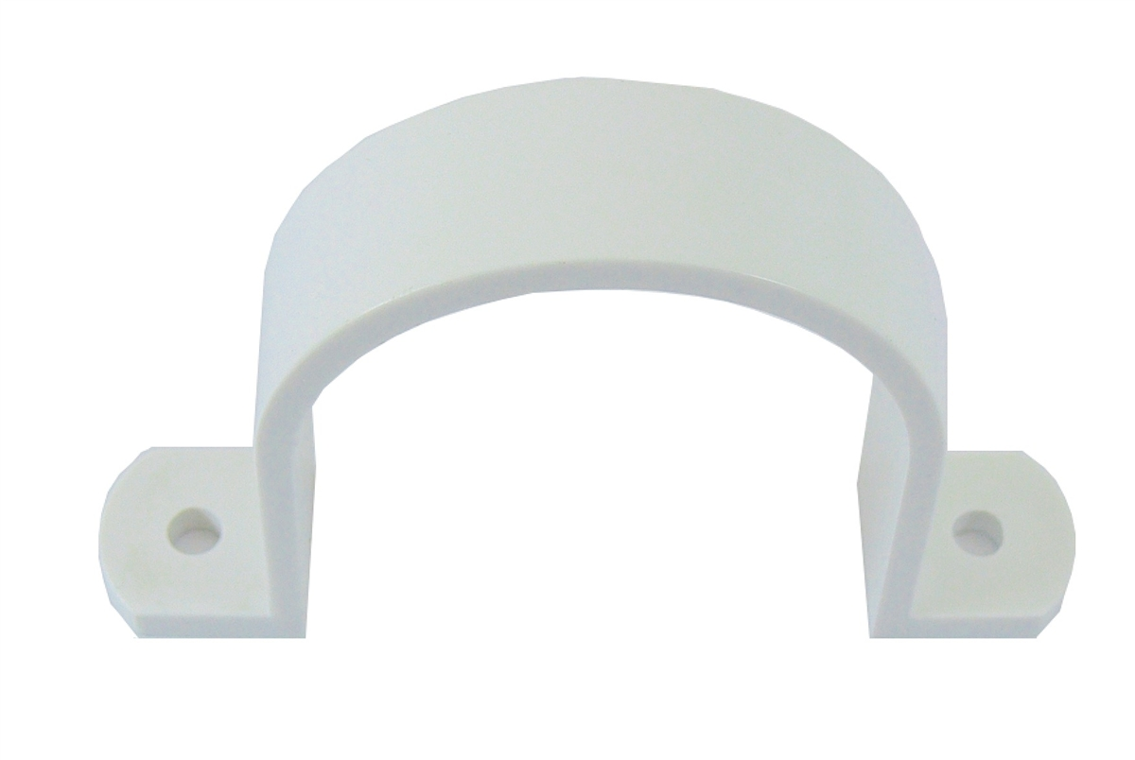
DO NOT cut and re-join the cables between Inlets
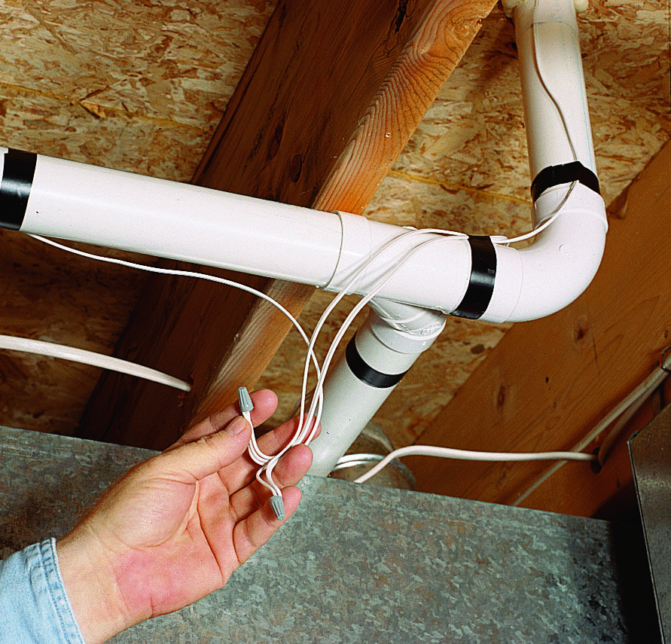

Step 10 – Finishing Off and Cleaning Up
Before leaving the site:
- Walk through the building making sure everything is complete,
- Draw a plan of all Pipe and Cable runs and mark all inlet locations on a diagram for future reference.
- Take Pictures of Each Inlet and the location of the Vacuum Motor, save these as if there is a issue such as the inlet plate being covered up OR not being there when you come back to fit off the system you have proof that it was there and you know where to start looking for the pipe.
- Make sure the Builder / Electrician know a power point is required near the Vacuum Motor.
- Remove ALL your off cuts and rubbish.

Other Inlet Options
(i) Sweep Inlet (sometimes called Vac Pan)
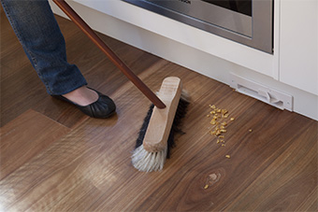
The Sweep Inlet is piped to the required location and treat it as a standard Inlet except the pipe is run to the floor with NO faceplate. Attach a piece of flexible hose to it so that when the Kitchen is installed then the Kitchen Installer can install the Sweep Inlet

As with ALL inlets an ON / OFF cable has to be run to it.

Leave the Sweep Inlet on site with the Builder / Owner for when the Kitchen is installed
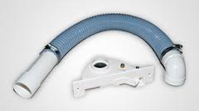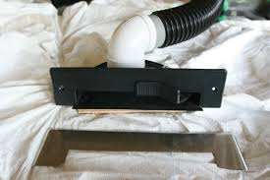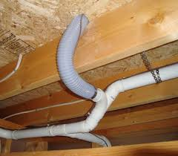

(ii) Wally Flex Inlet
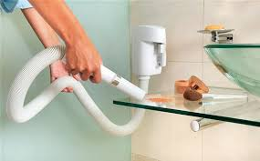
The Wally Flex Inlet is piped to the required location and treat it as a standard Inlet except the pipe
is run to about light switch height. Attach an Inlet face Plate. Like ALL inlets an ON / OFF cable has to be run to it

