

INSTALLATION

INSTRUCTIONS

FITTING HOSE SOCKS

TO CENTRAL VACUUM

HOSES

This information is distributed to all buyers of Hose socks from Central Vacuum Systems. It contains information which will be helpful to ensure that your hose sock is pulled tightly so it fits the hose from end to end and does not come away from one end.

If you have any questions please, don’t hesitate to seek advice from:

Central Vacuum Warehouse
Ph 03 3774658 or 0800 723 373
www.centralvacuumwarehouse.co.nz
sales@centralvacuumwarehouse.co.nz

FITTING HOSE SOCKS TO CENTRAL VACUUM HOSES

Section A: Over View
Non switched head Central Vacuum System hoses are usually 9 or 10 meters long.
Switched head Central Vacuum System hoses are usually 11 meters long

We supply both 9 and 11 meter hoses
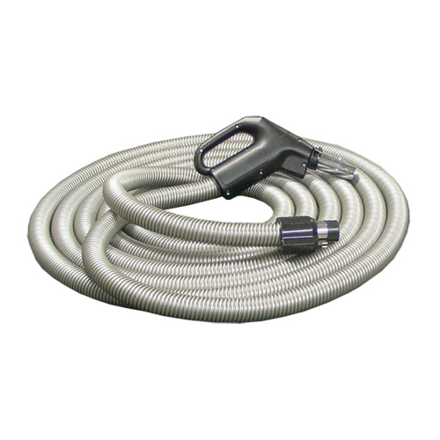
Section B: Equipment Required
1 x hose sock to fit your central vacuum hose

1 x Installation tube to fit over the hose, minimum size 65mm diameter (preferably 70mm diameter) and 600 long. Note: If you are running an extension lead along the hose to operate a powered head then this tube will need to be a minimum of 85mm and 600 long.
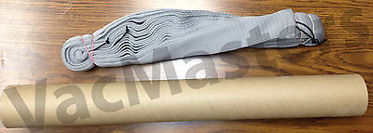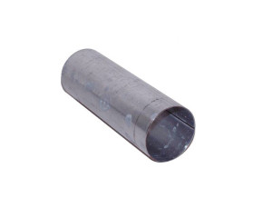

Section C: Fitting the Hose – see the picture below
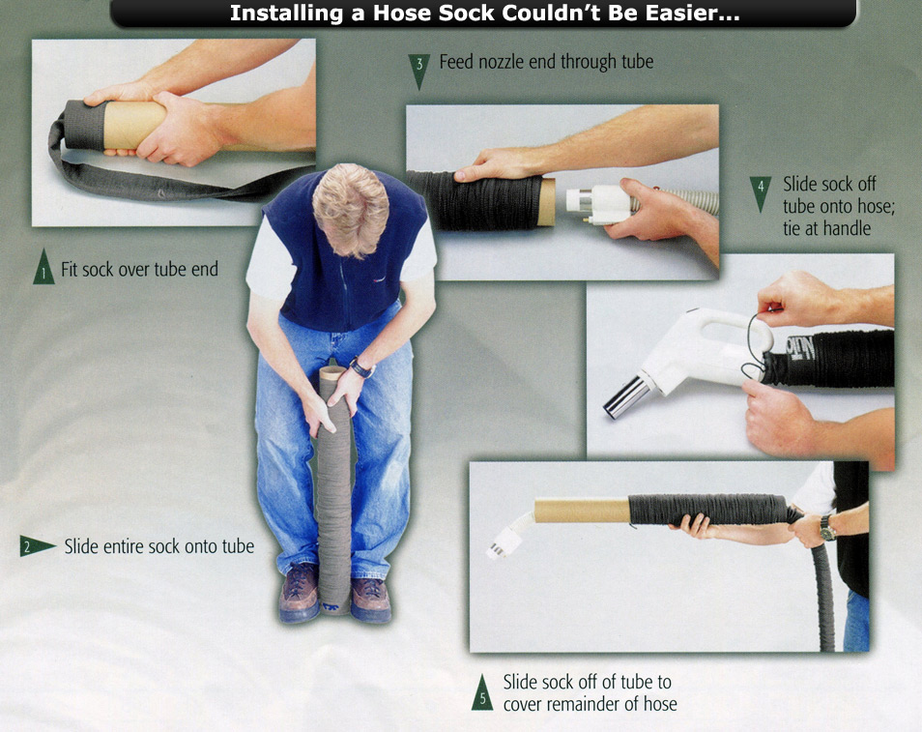

Step 1
Fit the Hose Sock over the end of your tube
Step 2
Push the entire hose over the tube; you will have to keep pushing the hose down so it all fits onto the tube.
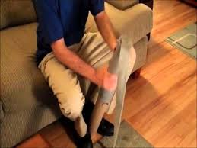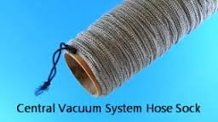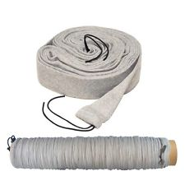

Step 3
Feed the inlet valve end through the tube
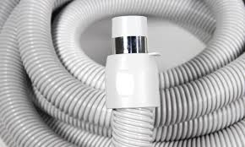
Note: If you are running an extension lead along the hose to operate a powered head then fit the female end of the extension lead through the tube as well.

Step 4
Lay the hose out on your floor and tie the handle one end to a door handle or something firm, then pull your tube with the hose sock on it down to the handle end of the vacuum hose. Note: If you are running an extension lead along the hose to operate a powered head then tape the extension lead to the every meter or so with enough hose at the handle to fit your powered head cable, maybe 60mm

Step 5
Tie the hose sock tightly to the hose handle OR around the top of the wand pipe

Step 6
Now move the tube with the hose sock on it back down the vacuum hose, stretching the hose tightly as you go so it does not bunch up on the hose
Note: Hose Socks are made to be stretched over the hose so when you are fitting MUST be stretched tight. This ensures they do not accumulate dust in any folds and are easy to brush clean

Step 7
Once you get to the end tie the hose off at the end with the fitting that goes into the inlet, you may have to work any excess sock back up the vacuum hose.

Section D: The finished Article
Your hose with the hose sock should look like this.
